1. Signup in Shopify
2. 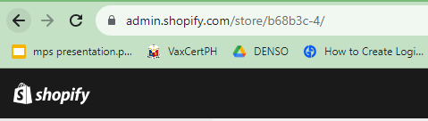Go to admin page
3. Click **Settings** from the Sidebar



1. Settings Dialog will popup. Click **Apps and sales channels** from the sidebar



1. Click Develop Apps on the upper right side



1. Click Create App



1. A dialog will popup, enter the details and create the app

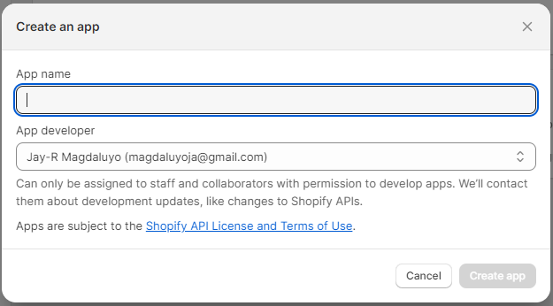

1. Configure admin API Scopes

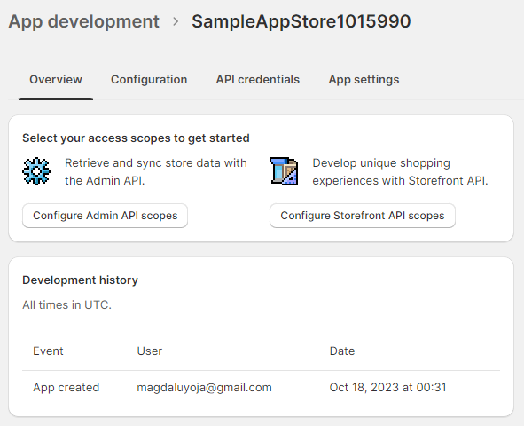

Search and select scopes then save

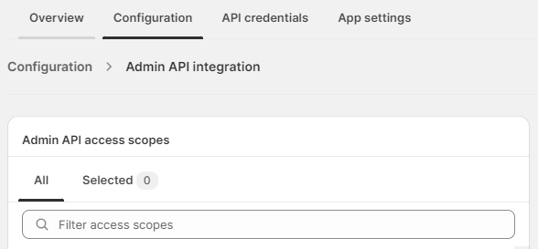

Click Install button to install the App to the Store



1. Secure API Credentials

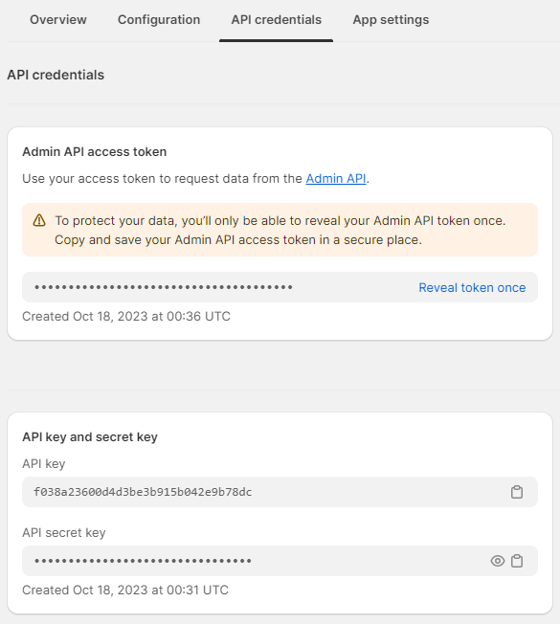

1. Refer to <https://shopify.dev/docs/api> to API Documentation